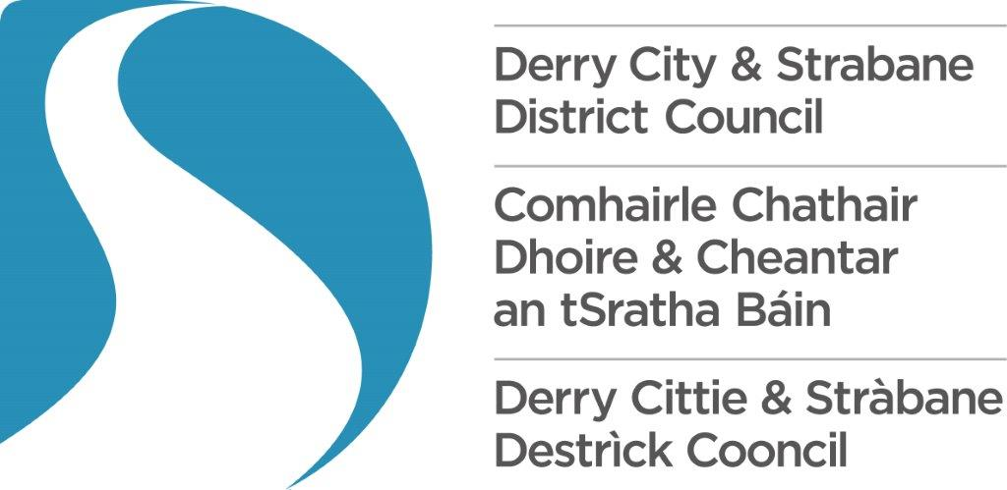
Headline Events Fund
2026/27

Guidance Notes

Introduction

The Headline Events Fund Application Form is used to apply for annual financial support from Derry City and Strabane District Council (DCSDC).

The primary purpose of the fund is to support large scale festivals with total visitor numbers (including participants) generated greater than 1,000, that can make a measurable contribution to priority outcomes identified in the community planning process and the DCSDC Tourism, and Arts and Culture strategies.

Headline Events have the potential to attract visitors from outside of the DCSDC area with the event showcasing the DCSDC area as a unique tourist destination.

Funding requests for values of up to £10,000 can be considered for Local Events of Scale that benefit the wider City and Region, without the minimum visitor requirement.

However, please note that applying to this process would rule ineligible an application through the DEA Consensual Grant Aid process for Community Festival Fund.

Who Can Apply?

The following section outlines the eligibility criteria for the Headline Events Fund. Your organisation must meet all of the following criteria in order to be eligible for this fund.

Your festival must satisfy the following requirements:

- Total visitor numbers (including participants) generated greater than 1,000 (Or maximum that the PHA guidance allows at the date of the event.
- Funding request from the DCSDC - £10,000 minimum, £30,000 maximum
- Funding requests for values up to £10,000 can be considered for Local Events of Scale that benefit the wider City and Region.
- However, please note that applying to this process would rule ineligible an application through the DEA Consensual Grant Aid process for Community Festival Fund.
- Overall public sector support cannot be more than 80% of event costs
- Headline Festivals must have a minimum overall budget of £50,000 (excluding in kind support) – successful applicants will be asked to provide evidence to support overall project spend.
- Local Events of Scale: (max. £10,000) the total grant amount can make up 100% of the total festival cost spend. (excluding in kind support)
- A threshold score of 50% of the marks must be reached in order to be eligible

Furthermore, your organisation must:

- Be a legally constituted group and supply evidence of this (e.g. constitution or memorandum and articles of association).
- Have an operational and festival programming focus in the DCSDC area.
- Be a not-for-profit organisation – see further details as below in italics

(Please note that DCSDC will not fund organisations that are:

not operating on a ‘not-for-profit’ basis (taken from the constitution or memorandum and articles of association) as we cannot support commercial projects or projects that could be carried out commercially. If, in the reasonable opinion of the Council, the Organisation applying for funding
is a de facto commercial Organisation, whatever the legal make-up of the Organisation, then the Council shall not fund that Organisation. The decision of the Council shall be final in this regard.

able to share out profits to individuals, members or shareholders (taken from the constitution or memorandum and articles of association);

- Have up-to-date annual and management accounts signed as agreed by the board or management committee and supply copies of same.
- Hold a bank account in the organisation’s name and provide evidence of this.
- Have a board or management committee.
- If relevant, have a child protection policy, vulnerable adults’ policy and equal opportunities policy and keep to relevant laws including the Race Relations (NI) Order 1997, the Sex Discrimination (NI) Order 1976, Fair Employment and Treatment (NI) Order 1998, and the Disability Discrimination Act 1995.
- Commit to completing required audience returns, based on a standardised sectoral methodology as defined by the NW Audience Development Programme

General Principles

This is a competitive scheme, and applications will be determined on the basis of merit.

Applications to this scheme will be open to all organisations that can meet the core criteria of the scheme. Applicants will be able to apply to other sources of public support.

Organisations in receipt of public funding must comply with all statutory obligations regarding the delivery of their programming and access to their events.

It is a prime responsibility of Council to ensure the proper and efficient use of and the accountability of public monies. To this end, festival organisations will be required to provide relevant supporting information when applying for funding.

The organisation completing the form must be the same organisation that will receive and manage the grant. We will not consider an application made by one organisation on behalf of another.

The deadline for submission detailed on the application form is absolute. Council will not accept late submissions to this fund nor fund retrospective costs incurred.

Assessment Process

Stage 1: Registration and Pre-Assessment

You must ensure that your organisation meets the eligibility criteria listed under “Who can apply?” through the completion of the Registration and Pre-Assessment form. Failure to complete this form will result in your application being deemed ineligible.

Stage 2: Application Form

Part A – Essential Details

This part of the application is not scored during the assessment process. However, failure to complete this section may result in your application being considered ineligible.

Part B – Community Planning Priorities

To be the cultural destination of choice and offer world class visitor services.

The DCSDC Tourism and Arts & Culture Strategies incorporate a number of impact measures.

The questions within this application form utilise a number of these key performance measures. The end of year impact assessment forms completed by grant aid recipients will be collated and will form the basis for evaluation reporting against these specific measures. For further information on the Tourism & Arts & Culture Strategies go to http://www.derrystrabane.com/Services/Arts-and-Culture/Arts-Culture-Strategy-2019-2024

http://www.derrystrabane.com/tourism

In Part B you will need to demonstrate how your organisation can help fulfil these outcomes.

Where possible we would like you to quantify how your organisation is making a contribution to the fulfilment of these outcomes.

Part C – Festival Impact

Question 11.A requires the completion of a table detailing impact, projected targets, including online audience targets regarding your programme of activities. Your targets should be appropriate to your organisation’s activities and size. Not all targets listed in application form will be relevant to all organisations. If any do not apply, write ‘N/A’ in the relevant box. You may also have other targets you want to detail.

Economic Impact

The response to Q.11.A&B is used to assess the projected economic impact of your festival based on the total number of local and non-local visitors, overnight stays and participant numbers etc as a direct consequence of staging the event. It is important that you present realistic figures for your festival as these will be subject to impact assessment.

In Q.11.B please ensure that you present a clear rationale and reference evidence for these overall figures as this score will be based on the rationale. .

Part D: Promotion of DCSDC

Positive media coverage can enhance the image of the DCSDC area as a destination of choice for potential visitors and provide Council and its partners with the opportunity to showcase our product and potential to a wide audience. We require you to provide detail on the nature and reach of your proposed marketing and PR activities and how you will highlight the contribution of DCSDC if your grant application proves successful.

Part E: Governance and Financial Management

In this section you should detail how your organisation ensures good governance and financial probity.

Part F: Proposed Grant Aid Spend

Please detail your entire projected core costs for 2026/27 including those items that you will use the funding for.

You should provide a detailed breakdown of exactly where the funding will be used. Successful applicants will be required to submit evidence of expenditure in their grant claim.

The Council reserves the right to attend your event as a pre-arranged or an unannounced visit in the interests of verification of the proper use of Grant Aid funding, evaluation, and adherence to your approved application.

Please note that failure to achieve a minimum Event Spend of £50,000 as set out in the award criteria may result in financial penalties e.g., ‘claw back’ of grant award. Failure to disclose at the application stage, full financial details relating to your event funding may impact future funding awards.

How does the fund work?

- There is one round of funding for the financial year 2026/27.
- You can apply for any amount up to a maximum of £30,000 excluding in kind support.
- Only one successful festival application (Consensual, Local Events of Scale or Headline Event) can be held by any organisation in the 2026/27 financial year.
- The fund will cover both Project Costs and Core Costs. Eligible core costs include infrastructure, programming, and overheads. Ineligible core costs include hospitality, alcohol, salaries & wages, repayments of debts, retrospective grants or capital build expenditure. Please note equipment purchased must be clearly linked to the festival.
- The funds are awarded in order of merit, working from the top score downwards, until the allocation of funds is exhausted.
- The Fund will not fund Festivals where the applicant will have a personal financial benefit. No employees of the Organisation may enter into any arrangement in respect of the Project in addition to their roles as employee or board member of the Organisation, to supply goods, facilities or services to the Project for payment.
- Any expenditure incurred in relation to cost of entry and or use, hire or occupation of premises owned by the recipient will be deemed ineligible.
- You will be required to submit a Festival Risk Assessment and a Festival Plan six weeks in advance of your event for consideration by the DCSDC Safety Advisory Group.
- You must also complete and provide all monitoring and evaluation requirements for previous years’ grant allocations before a further allocation for a festival will be considered.

Preparing your application

Note: Remember to stay within the defined word count for each question. Content beyond the defined word count will not be considered during assessment. You cannot attach additional information with your application.

Question 1 - 2 (Part A)

This section is for information only and will not form part of the assessment process.

Question 3 – 13 (Part B, C, D & E)

For guidance on completing Questions 3 – 14 please refer to the attached document entitled ‘Scoring Matrix’.

Question 14– 15 (Part F)

This section requires you to detail how you will utilise the grant aid.

This question offers you the opportunity to identify what costs you will incur within the five columns provided as follows:-.

Column One - Expenditure Details: this column should set out the specific cost headings related to your application e.g., ‘artists fees’.

Column Two - Itemised Costs: e.g. if you are paying a facilitator/artist, how much do they charge per day/session/hour. If you are buying project linked equipment, itemise each piece of equipment.

Column three - Total costs: if you have shown a daily rate or item cost, for example facilitator or materials, this column will show the total cost and so will link to your Project/Service description e.g., three days facilitation, materials per person.

Column Four - Amount required from DCSDC: you must identify those costs or element of costs detailed in column two against which you intend to make a grant claim. Evidence of expenditure will be required as part of your grant aid claim.

Column Five - Who will fund the remainder: you may already have secured funding for some of your costs or identified where you will go for further funding support e.g., ACNI, TNI, sponsorship etc.

Be realistic when you are putting your costs for the Project into your application and remember that your costs must be proportionate to the overall costs of your Project and essential for delivering it.

If we do not think that the amount you have asked for is good value for money, we may offer you less than the amount you applied for.

Assessing officers have the discretion to reduce or disallow expenditure deemed inappropriate to the delivery of the Project.

How will decisions be made?

DCSDC may not be able to fund all successful applicants or support the maximum available grant award if there are more demand than there is funding available. However, all applications will be considered carefully. They will be looked at and assessed by a panel of Council Officers and ratified by both the Business and Culture Committee and Full Council.

General Data Protection Regulations & Freedom of Information

General Data Protection Regulations
We will use the information you give us on the application form during assessment and for the life of any grant we award you to administer and analyse grants and for our own research.
We may give copies of this information to individuals and organisations we consult with when assessing applications, when monitoring grants and evaluating the way our funding programmes work and the effect they have. These organisations may include accountants, external evaluators and other organisations or groups involved in delivering the project.
We may also share information with other government departments, organisations providing match funding and other organisations and individuals with a legitimate interest in applications and grants, or for the prevention or detection of fraud.
We might use the data you provide for our own research. We recognise the need to maintain the confidentiality of vulnerable groups and their details will not be made public in any way, except as required by law.
We will dispose of the information we hold when we no longer require it and in line with our Retention and Disposal policy.
For further information, please visit the Council’s web page at http://www.derrystrabane.com/Footer/Privacy-Policy.

Freedom of Information Act
The Freedom of Information Act 2000 gives members of the public the right to request any information that we hold, subject to certain exemption that may apply. This includes information received from third parties, such as, although not limited to, grant applicants, grant holders and contractors.

If information is requested under the Freedom of Information Act we will release it,
subject to exemptions; although we may consult with you first. If you think that information you are providing may be exempt from release if requested, you should let us know when you apply.

For further information please visit the Council’s web page at http://www.derrystrabane.com/Council/Freedom-of-Information or the Information Commissioner’s Office at https://ico.org.uk/global/contact-us/

Review Procedure
If you believe the Funding Process has not been followed correctly or your application has been incorrectly scored you may request a Review within seven working days of receiving your Letter of Outcome in writing to:

Mr Stephen Gillespie
Director of Business and Culture
Council Offices
98 Strand Road
Derry
BT48 7NN

A Senior Council Officer will review the process and equality of scoring within the round and respond to your Review Request.

