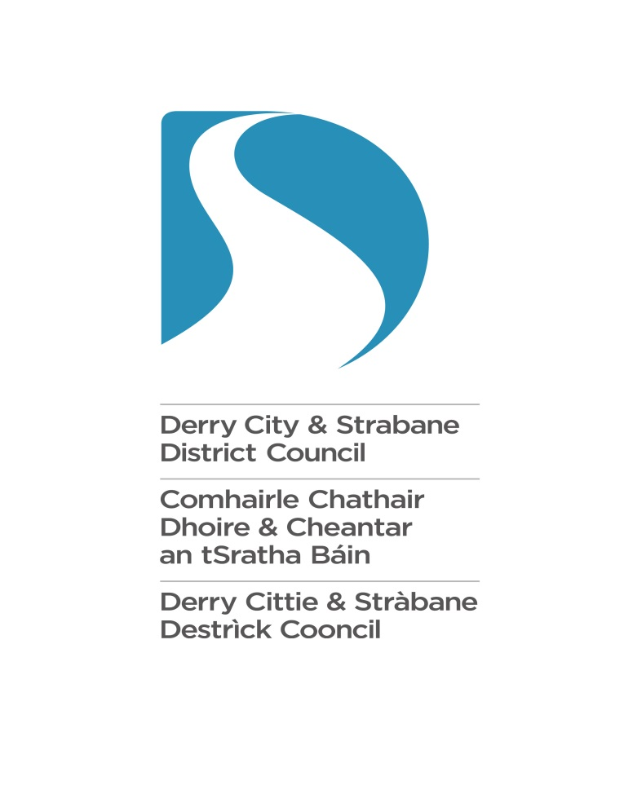

Good Relations Strategic Priority Fund (SPF) 2026/27

Guidance Notes

Introduction

The Good Relations Strategic Priority Fund Application Form is used to apply for financial support from Derry City and Strabane District Council.

The fund is open to constituted ‘Not for Profit’ organisations that are open, accountable and representative of the geographical area which they serve and wish to submit an application to promote Good Relations.

The fund is here to help your good ideas take root and grow.

What is Good Relations?

Good Relations is about equity, diversity and interdependence. Our vision is that Derry City and Strabane District will be prejudice free, diverse and cohesive. We will work with others to build a City and District where all people have a strong and equal sense of belonging. It’s about making a meaningful difference locally to attitudes and actions, policies and places in a society in transition from conflict to lasting peace. For further information, you may wish to read the government strategy which outlines these issues: https://www.executiveoffice-ni.gov.uk/topics/together-building-united-community-tbuc

You can also contact your local Good Relations Team in the Derry City and Strabane District Council area who may be able to provide additional information and reference points for research and statistics regarding the need for specific Good Relations initiatives locally. We are in the process of developing a new Good Relations Strategy 2026-29, to be published later this year. However, the current Good Relations Strategy 2022-2025 can be referenced. It can be accessed at:

https://www.derrystrabane.com/community/good-relations/good-relations-strategy-2018-2021

The Equality Commission defines the promotion of Good Relations as follows:
“The growth of relationships and structures for Northern Ireland that acknowledge the religious, political and racial context of this society, and that seek to promote respect, equity and trust, and embrace diversity in all its forms.” (2008)

Section 75 of the Northern Ireland Act 1998 is the legal context of Good Relations. It places
a statutory obligation on public authorities to:
“Have regard to the desirability of promoting good relations between persons of different religious belief, political opinion, and racial group.”

Together: Building a United Community - Themes

The Government’s ‘Together: Building A United Community Strategy’ (2013) states that Good Relations must fall within four key themes. Applications must adhere to one or more of these themes and ensure that Good Relations is the primary focus of their application.

Children and  Young People | Aim: to continue to improve attitudes amongst our young people and to build a community where they can play a full and active role in building Good Relations.
Our Shared  Community | Aim: to create a community where division does not restrict the life opportunities of individuals and where all areas are open and accessible to everyone.
Our Safe  Community | Aim: to create a community where everyone feels safe in moving around and where life choices are not inhibited by fears around safety.
Our Cultural  Expression | Aim: to create a community which promotes mutual respect and understanding, is strengthened by its diversity, and where cultural expression is celebrated and embraced.

107
What Is The Strategic Priority Fund

All staff and councillors and many public and community organisations were consulted in developing the current Good Relations Strategy and to get feedback on possible changes to make it more effective.
The audit suggested that Council could further strengthen the strategic impact of existing consensual and other local area funding through a cross-cutting strategic priority each year with a substantial allocation of TEO funding. The audit also recommended that rural areas must be properly included in funding for this cross-cutting priority. This fund was therefore agreed and included in the Good Relations Strategy for Derry City and Strabane District Council 2022-2025.

Derry City and Strabane District Inclusive Strategic Growth Plan 2017-2032

Good Relations is a key theme in the Derry City and Strabane District Inclusive Strategic Growth Plan 2017-2032. Your application will need to show how your project clearly aligns with a minimum of 3 outcomes and the actions from the plan which are detailed in one of the questions in the application form.

The Inclusive Strategic Growth Plan can be downloaded here:

https://www.derrystrabane.com/about-council/community-planning/inclusive-strategic-growth-plan-our-community-plan

How Does the Fund Work?

- There is one round of funding this financial year 2026/27. Any monies spent prior to 1st April 2026 are ineligible.

- You can apply for project costs up to a maximum of £10,000.

Whatever you decide to do, please remember:

- The project/service should make a real difference to people who live in the Derry City and Strabane District Council area.

- You must be able to show that there is a need for the project/service as you will be asked to demonstrate this.

- Verifications will be carried out on your project as it progresses. You must provide the required information to the Council officer during verifications.

- You must demonstrate how your project contributes to a safer community

Who Can Apply?

Constituted Community and Voluntary Sector organisations with a base in the Derry City and Strabane District Council area and which promote Good Relations. You will have to confirm you have good governance in place – including insurance, financial accounts and relevant documentation. Groups that already hold funding or who have applied for funding from Council (e.g. Consensual grants) are eligible to apply to this fund.

The form has 2 sections:

Registration All applicants must fill in this section.
Application for Project
.

Do not send additional documentation (that is checked later if you are offered funding). Applications must score over 60% to reach the threshold for funding.

A note in relation to Good Relations Strategic Priority Fund

The Good Relations Strategic Priority Fund 2026-27 Application Form is used to apply for financial support from Derry City and Strabane District Council (DCSDC).

The Good Relations Strategic Priority Fund provides support for organisations which are considered of strategic importance in promoting Good Relations work in the Council area. These are organisations whose main body of work is in Good Relations and are delivering projects that are specifically designed for those purposes. While organisations may deliver on other identified outcomes such as poverty, education, sport etc. to be successful, the bulk of their delivery will be based on Good Relations outcomes only.

Applicants will need to demonstrate how their project meets this objective and at least two of the outcomes from the Together Building a United Community (TBUC) Strategy. To ensure strategic alignment with other strategies, applicants will need to outline how their project will impact on the objectives of the following strategies: DCSDC Good Relations Strategy, Ending Violence Against Women and Girls Strategy and DCSDC Inclusive Strategic Growth Plan.

Applications are for projects up to £10,000. This is a competitive fund with a limited budget.
- A Project is generally defined as being time bound with a very specific start and end date. Applications may include costs such as facilitation fees, room hire, catering, etc.*
- Project costs can also include a relevant percentage of core costs like running costs or salaries but only if these are clearly explained and directly attributable to the project being applied for.
- N.B. Salaries and management costs cannot both be funded under this programme. Please be aware that while you can apply to numerous funders for the same specific costs, you may only accept one offer of funding

*Please see page 6 of these Guidance Notes for caps/restrictions

Strategic Priority Fund Criteria

The funding programme will operate at City and District wide level to support organisations who are Good Relations practitioners, offering these groups the opportunity to address Good Relations issues at strategic level across the Council area. This includes addressing community tensions, identifying GR issues, addressing and implementing initiatives to overcome core challenges related to issues such as sectarianism, racism, cultural diversity, inclusion and social cohesion.
- Funding is intended for strategic projects that can make a measurable contribution Good Relations
- Applicants must demonstrate how their project links with and impacts on outcomes within the following strategies:
- Together Building a United Community Strategy
- DCSDC Good Relations Strategy 2022-25
- Ending Violence Against Women and Girls Strategy
- DCSDC Strategic Growth Plan
- Applicants will be asked to demonstrate what other funding has been secured for their project, the amount and duration of funding. Applicants will have to provide evidence of other funding awards.

The following are not eligible for funding
- Projects that do not directly benefit Derry City and Strabane District Council residents
- Alcohol
- Projects that have already been completed
- Projects that do not promote the theme of Safe Communities
- The costs of hire of inflatables over 25% of the approved grant
- Catering/refreshments/hospitality over 25% of the approved grant
- Costs that are not auditable i.e. cash payments
- Repayments of debts, retrospective grants or capital build expenditure
- Where the primary objective of a project is to raise money for charity
- Projects must be additional to the usual business of the applicant organisation
- Applications for Community Safety Warden Schemes will not be considered in this fund
- Activities or programmes which are the responsibility of another statutory agency will not be considered under this fund.
Guidance on Answering Questions in the Form

Q1. Please ensure that you give a comprehensive overview of the project and clearly state how it meets the Strategic Priority Fund criteria.

Q2. Please provide detail on the impact of the project and how it will contribute to improving Good Relations in the area.

Q3. Please ensure that all your answers are relevant to this funding programme. It is good practice to take each element and answer each separately as marks are allocated for each element and clearly shown on the application form.

Q4. Please ensure that you demonstrate that you are a Good Relations practitioner and that your organisation has carried out Good Relations programmes.

Q5. Please provide details of what the issues are and provide evidence of need for the project. Refer to as many evidence sources as possible.

Q6. Ticking multiple outcomes does not necessarily result in a higher score. It is important that the explanation of how the project addresses at least two outcomes is clearly set out.

Q7. Not Scored.

Q8. It is important that you outline how your project links with and impacts all of the strategies listed. Points are available for links made with each strategy.

Q9 Please detail the person who will manage the project and their/your organisation’s experience in managing similar projects. Experience of managing/claiming funding should be outlined, as well as monitoring and evaluation and dealing with unexpected circumstances.

Q10. Please ensure that as much detail as possible is given about costs including a full breakdown. Failure to do so may result in points being deducted.

Q11. Please give details of funding already secured for your project which is additional to funding from DCSDC.

Contact with Derry City and Strabane District Good Relations Team:

Officers will be able to provide advice prior to completing your Pre-Assessment and Application Form. Assistance will only be available during office hours: 9:00 a.m. – 5:00 p.m. Monday to Friday. Please note, officers can only advise on the process, not the content of your application. Officer contact details:

Amanda Biega Tel: 028 71253253 ext. 4298 amanda.biega@derrystrabane.com
Mobile Number: 07592103843

Martin Gallagher Tel: 028 71253253 ext. 6984 martin.gallagher@derrystrabane.com
Mobile Number: 07841927591

Louise Kitson Tel: 028 71253253 ext. 6769 louise.kitson@derrystrabane.com
Mobile Number: 07889651195

How will decisions be made?

Derry City and Strabane District Council may not be able to fund all projects which score over the threshold for funding as there may be more applications than funding available. However, all applications will be considered carefully. Applications will be assessed by a panel of Council Officers and ratified by both the Health and Community Committee and Full Council.

General Data Protection Regulations (GDPR)

Derry City and Strabane District Council will use the information you give us on the application form during assessment and for the life of any grant we award you to administer and analyse grants and for our own research.
We may give copies of this information to individuals and organisations we consult with when assessing applications, when monitoring grants and evaluating the impact of our funding programmes. These organisations may include accountants, external evaluators and other organisations or groups involved in delivering the project.
We may also share information with other government departments, organisations providing match funding and other organisations and individuals with a legitimate interest in applications and grants, or for the prevention or detection of fraud.
We might use the data you provide for our own research. We recognise the need to maintain the confidentiality of vulnerable groups and their details will not be made public in any way, except as required by law.
We will dispose of the information we hold when we no longer require it and in line with our Retention and Disposal Policy.
For further information, please visit the Council’s web page at https://www.derrystrabane.com/privacy-policy
Freedom of Information Act

The Freedom of Information Act 2000 gives members of the public the right to request any information that we hold, subject to certain exemptions that may apply. This includes information received from third parties, such as, although not limited to, grant applicants, grant holders and contractors.

If information is requested under the Freedom of Information Act we will release it,
subject to exemptions; although we may consult with you first. If you think that information you are providing may be exempt from release if requested, you should let us know when you apply.

For further information please visit the Council’s web page at https://www.derrystrabane.com/about-council/freedom-of-information or the Information Commissioner’s Office at https://ico.org.uk/global/contact-us/

Review Procedure
If you believe the funding process has not been followed correctly, you have the right to request a review within seven working days of receiving your Letter of Outcome in writing to:

Barry O’Hagan
Head of Community Development and Leisure
Health and Community Directorate
Derry City and Strabane District Council
98 Strand Road
Derry
BT48 7NN

A Senior Council Officer will review the process and respond to your request.

Deadline for submission of applications

Applicants should use the online portal https://www.dcsdcgrantaid.com/ for submissions and are reminded that the deadline is 3.00 p.m. on Wednesday 22nd April 2026.
Applicants are encouraged to submit their application early as this deadline is absolute. Please do not wait until near the closing time to submit your application. Under no circumstances will an application be deemed eligible after the 3:00 p.m. deadline.

Be aware of the speed of your internet connection, your system configuration and the volume of general web traffic that may impact on the time required to upload your application.

If you are submitting your application in an alternative format, you should send it to either of the addresses below, ensuring that you allow adequate time for it to be received by the deadline for applications:

Good Relations Strategic Priority Fund 2026/27
Health and Community Directorate
Community Development Section
Derry City and Strabane District Council
98 Strand Road
Derry BT48 7NN

Or

Good Relations Strategic Priority Fund 2026/27
Health and Community Directorate
Community Development Section
Derry City and Strabane District Council
47 Derry Road
Strabane BT82 8DY

