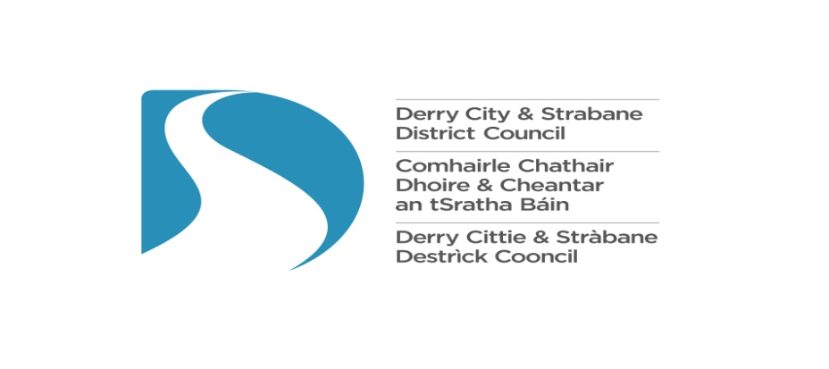

DCSDC
Artist and Cultural Practitioner Award
2026/27

Guidance Notes

Introduction

This Award has been created by Derry City & Strabane District Council in order to fulfil action ‘2k’ under Aim 2 of the Arts & Culture Strategy (2019-24) to ‘Deliver quality programme, product and practice’.

The Arts & Culture strategy is designed to complement Councils Tourism Strategy and Integrated Economic Development Strategy. It has been aligned with the outcomes identified within the Strategic Growth plan and is cognisant of the wider strategic and cross border environment.

The strategy consultation process was based on a co-design methodology to promote creativity and collaboration, establishing a Co Design group to drive the development of the strategy. The Arts & Culture Co Delivery Group made up of nominated representatives from across the sector, including individual artists and elected representatives, oversee the implementation of the strategy.

One of the most significant and recurring issues identified during the consultation for the Arts & Culture Strategy was the lack of direct support available for artists and practitioners. The consultation participants articulated the requirement of established and emerging artists to travel beyond DCSDC to access opportunities. In many cases these creative individuals made their move out of the City and District permanent.

Specifically the action within the Strategy states the requirement to:

Create a dedicated fund in Derry City and Strabane District to support independent Artists, theatre makers and arts organisations in the creation and dissemination of new artistic work. Commission quality local and international artists to create artworks linked to learning opportunities for programmes and events with the aim of inspiring audiences and practitioners.

This fund aims to support individual artists and practitioners based in Derry & Strabane, supporting opportunities for the artist (s) and/ or cultural practitioners to undertake one or more of the following:

- Skills development & learning opportunities
- Enhanced profiling and career development opportunities
- Creation of new artworks
- Resources directly linked to project proposal e.g. equipment / artist space
- Opportunities to meaningfully engage participants
- Opportunities to inspire audiences/ reach new audiences

Who Can Apply?

This award is available to artists, practitioners and cultural organisations resident within the DCSDC area.

Organisations in receipt of other Cultural Grant Aid from Council (Cultural Organisations, Headline Events, Community Festivals or Heritage Animation) in the same year are not eligible for this award.

General Principles

- This is a competitive scheme and applications will be determined on the basis of merit.
- Council will make only one award per artist/organisation.
- Collaborative projects are welcomed. However, the individual/ organisation completing the form must be the same individual/ organisation that will receive and manage the grant. We will not consider an application made by one individual/ organisation on behalf of another.
- In 2026/27 Council are seeking to support new entrants, new projects or projects that demonstrate sufficient development from previous successful applications made under the Artist & Cultural Practitioner Awards.
- Organisations in receipt of public funding must comply with all statutory obligations regarding the delivery of their programming and access to their events.
- The deadline for submission detailed on the application form is absolute. Council will not accept late submissions to this fund nor fund retrospective costs incurred.

How does the fund work?

- There is one round of funding for the financial year 2026/27. This call will relate to projects / events taking place in the financial year 1st April 2026 – 31st March 2027.
- Projects / events taking place will be supported up to a maximum of £1,000 and all financial spend of your proposed event must be spent and vouched by 31st March 2027.
- This award is for one off, unique projects and will not support existing events, events that are already receiving funding from council. However, applicants can apply to other sources of public support.
- The award will cover both Project Costs and Core Costs. Eligible core costs include infrastructure, equipment, programming and overheads. Ineligible core costs include hospitality, alcohol, repayments of debts, retrospective grants or capital build expenditure. Please note equipment purchased must be clearly linked to the project and demonstrate good value for money.
- Where artist fees feature as part of the proposal these must be consistent with ACNI defined rates and demonstrate good value for money.
- Residencies or programming beyond the DCSDC boundaries will be considered eligible within this programme as long as the applicant can demonstrate benefit for the local cultural ecosystem.
- You must also complete and provide all reporting, monitoring and evaluation requirements as required.

How will decisions be made?

DCSDC may not be able to fund all successful applicants, or support the maximum available grant award if there are more demand than there is funding available. However, all applications will be considered carefully. They will be looked at and assessed by a panel of Council Officers and ratified by both the Business and Culture Committee and Full Council.

General Data Protection Regulations & Freedom of Information

General Data Protection Regulations
We will use the information you give us on the application form during assessment and for the life of any grant we award you to administer and analyse grants and for our own research.

We may give copies of this information to individuals and organisations we consult with when assessing applications, when monitoring grants and evaluating the way our funding programmes work and the effect they have. These organisations may include accountants, external evaluators and other organisations or groups involved in delivering the project.

We may also share information with other government departments, organisations providing match funding and other organisations and individuals with a legitimate interest in applications and grants, or for the prevention or detection of fraud.
We might use the data you provide for our own research. We recognise the need to maintain the confidentiality of vulnerable groups and their details will not be made public in any way, except as required by law.

We will dispose of the information we hold when we no longer require it and in line with our Retention and Disposal policy.

For further information, please visit the Council’s web page at http://www.derrystrabane.com/Footer/Privacy-Policy

Freedom of Information Act
The Freedom of Information Act 2000 gives members of the public the right to request any information that we hold, subject to certain exemption that may apply. This includes information received from third parties, such as, although not limited to, grant applicants, grant holders and contractors.

If information is requested under the Freedom of Information Act we will release it, subject to exemptions; although we may consult with you first. If you think that information you are providing may be exempt from release if requested, you should let us know when you apply.

For further information please visit the Council’s web page at http://www.derrystrabane.com/Council/Freedom-of-Information or the Information Commissioner’s Office at https://ico.org.uk/global/contact-us/

Review Procedure
If you believe the Funding Process has not been followed correctly or your Application has been incorrectly scored you may request a Review within seven working days of receiving your Letter of Outcome in writing to:

Mr Stephen Gillespie
Director of Business and Culture
Council Offices
98 Strand Road
Derry
BT48 7NN

A Senior Council Officer will review the process and equality of scoring within the round and respond to your Review Request.

